**NAME:**

**PROBLEM 1:** For each of the stress states listed below evaluate the failure of the material for the following two materials: Steel Sys=250MPa and Cast Iron Stuci=170MPa/ Scuci=655MPa. Determine if failure occurs and if it does not, determine the safety factor. Be sure to state the criteria you are using for failure.

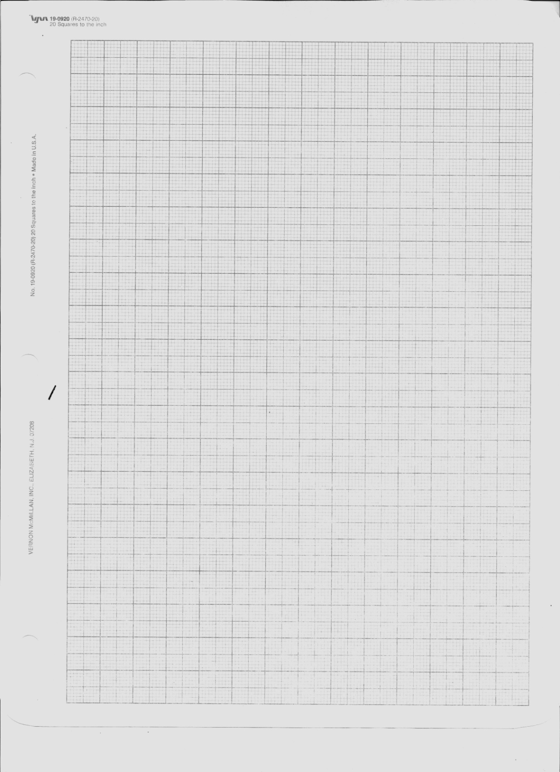**1a (10pts).** 

**1b (10pts).** 

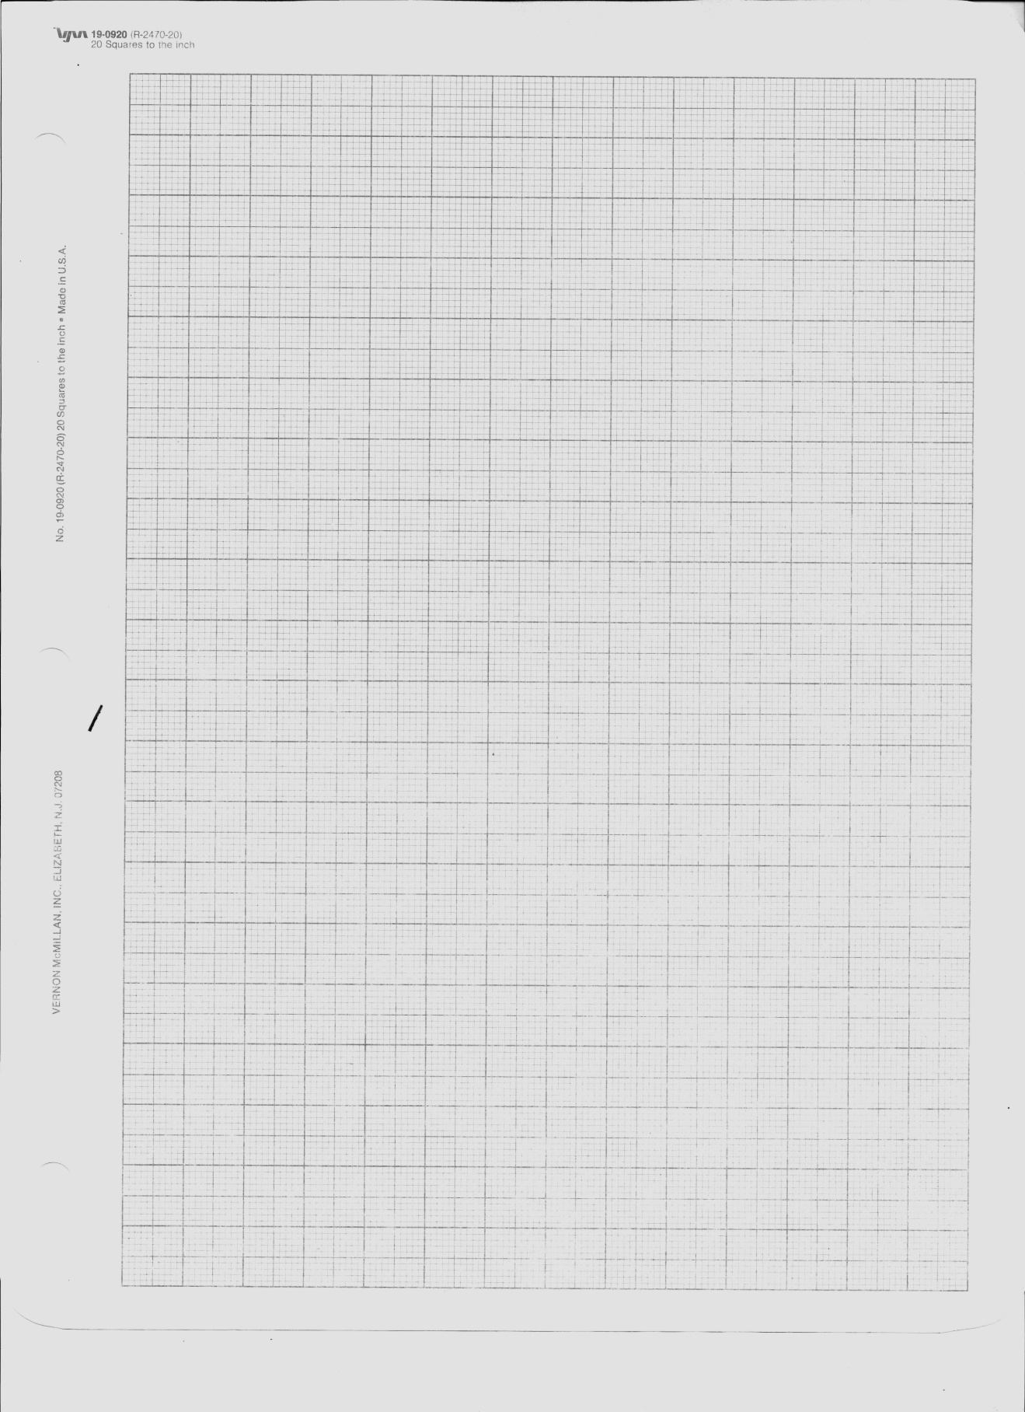

**1c (10pts).** 



**PROBLEM 2:** A 34 foot long hollow circular column is constructed out of structural steel with a yield strength of σy=30 ksi and a modulus of elasticity of E=30 Msi. The cross-sectional properties of the column are A=8.640 in2 and I=32.94 in4.

**2a (10pts).** Given both ends are pinned, what is the critical buckling load?

**2b (10pts).** Given both ends are fixed, what is the critical buckling load?

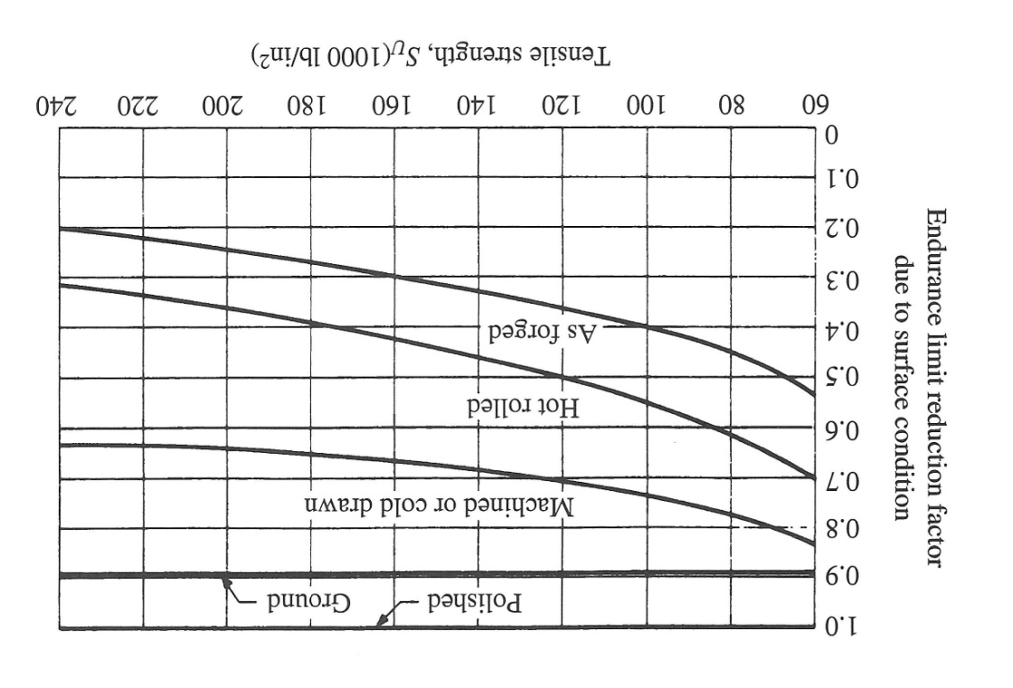**PROBLEM 3:** A mechanical part is made of machined steel with the properties Su=560 MPa (81.2 ksi) and Sy=490 MPa (71.1ksi).

**3a (10pts).** Draw the S-N diagram for this material on the paper provided on the next page. Make sure to label the axes and all important points with values.

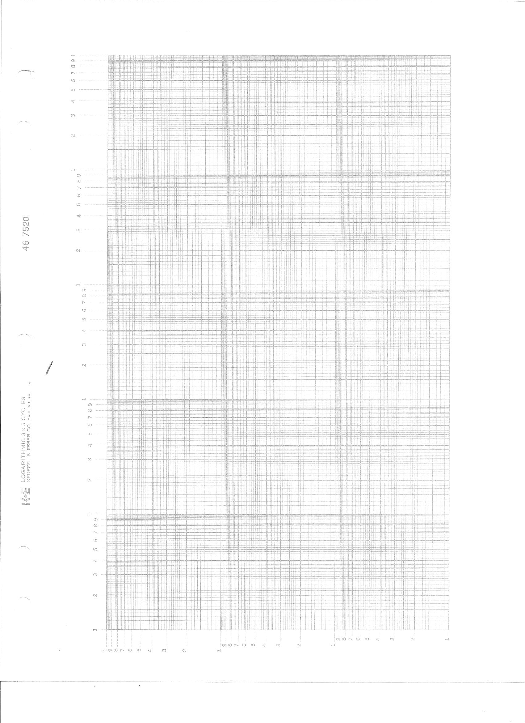

**3b (10 points).** What is the equation of the S-N diagrams line? What is the slope of the line? What is the lines intercept?

**3c(10pts).** The part is subjected to a bending stress that alternates between 100 MPa and 200 MPa. Using the paper provided on the next page draw the Modified Goodman diagram for this material and illustrate the location of the state of stress under consideration. Make sure to label all important values on the diagram.

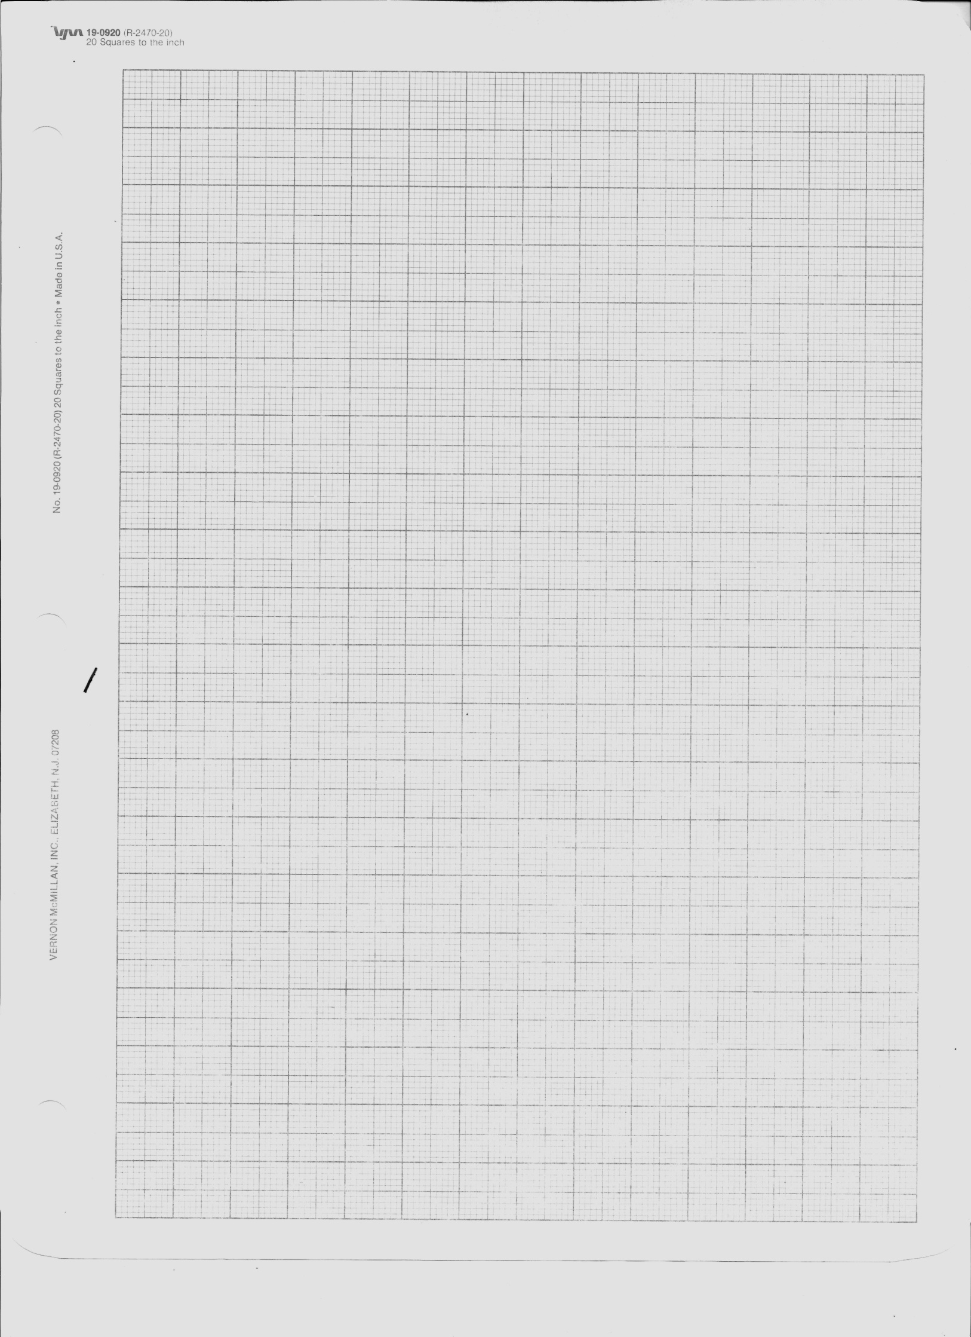

**3d (10 pts).** Add to the Modified Goodman diagram a line that corresponds to the finite life of 200,000 cycles.

**3e (10 pts).** Evaluate the factor of safety corresponding to a finite life of 200,000 cycles.